

Dealing with

Missing Valves in Python

IBM Developer

SKILLS NETWORK

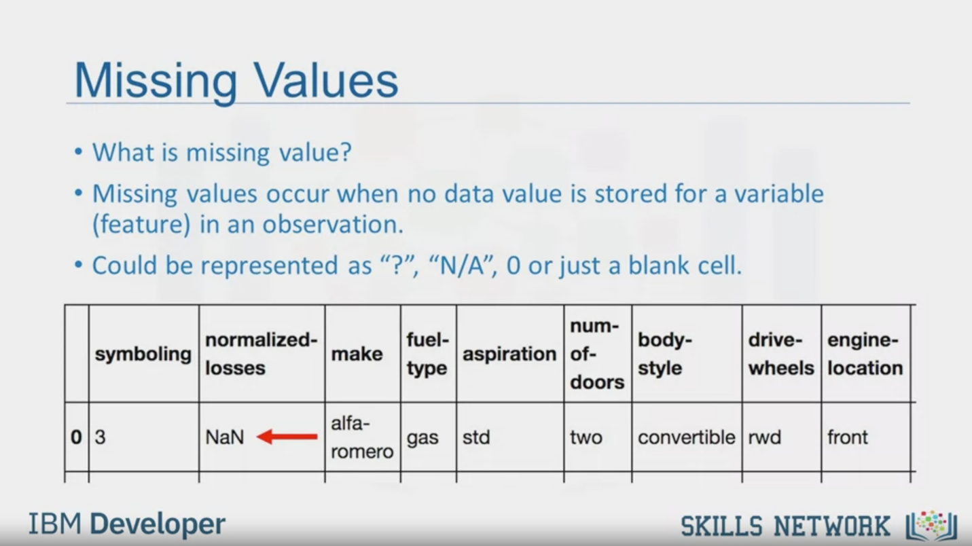

Missing Values

• What is missing value?

• Missing values occur when no data value is stored for a variable

(feature) in an observation.

• Could be represented as "?", "N/A", O or just a blank cell.

IBM Developer

SKILLS NETWORK

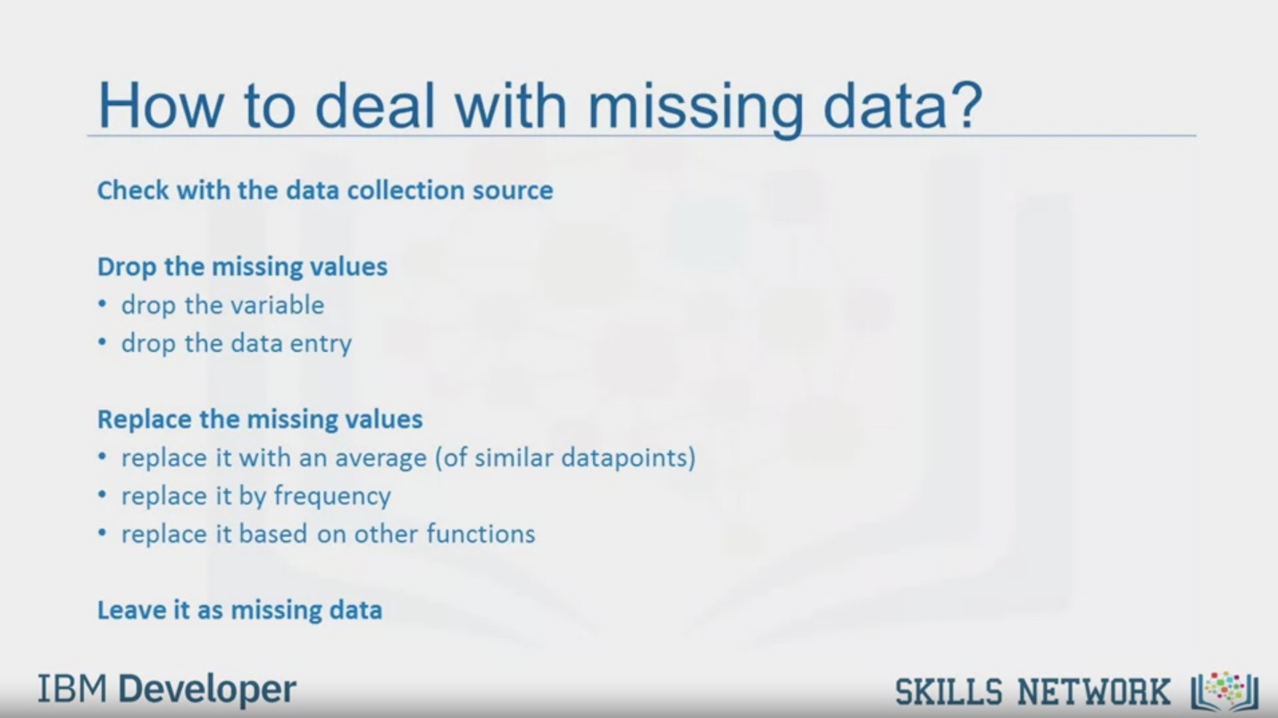

How to deal with missing data?

Check with the data collection source

Drop the missing values

• drop the variable

• drop the data entry

Replace the missing values

• replace it with an average (of similar datapoints)

• replace it by frequency

• replace it based on other functions

Leave it as missing data

IBM Developer

SKILLS NETWORK

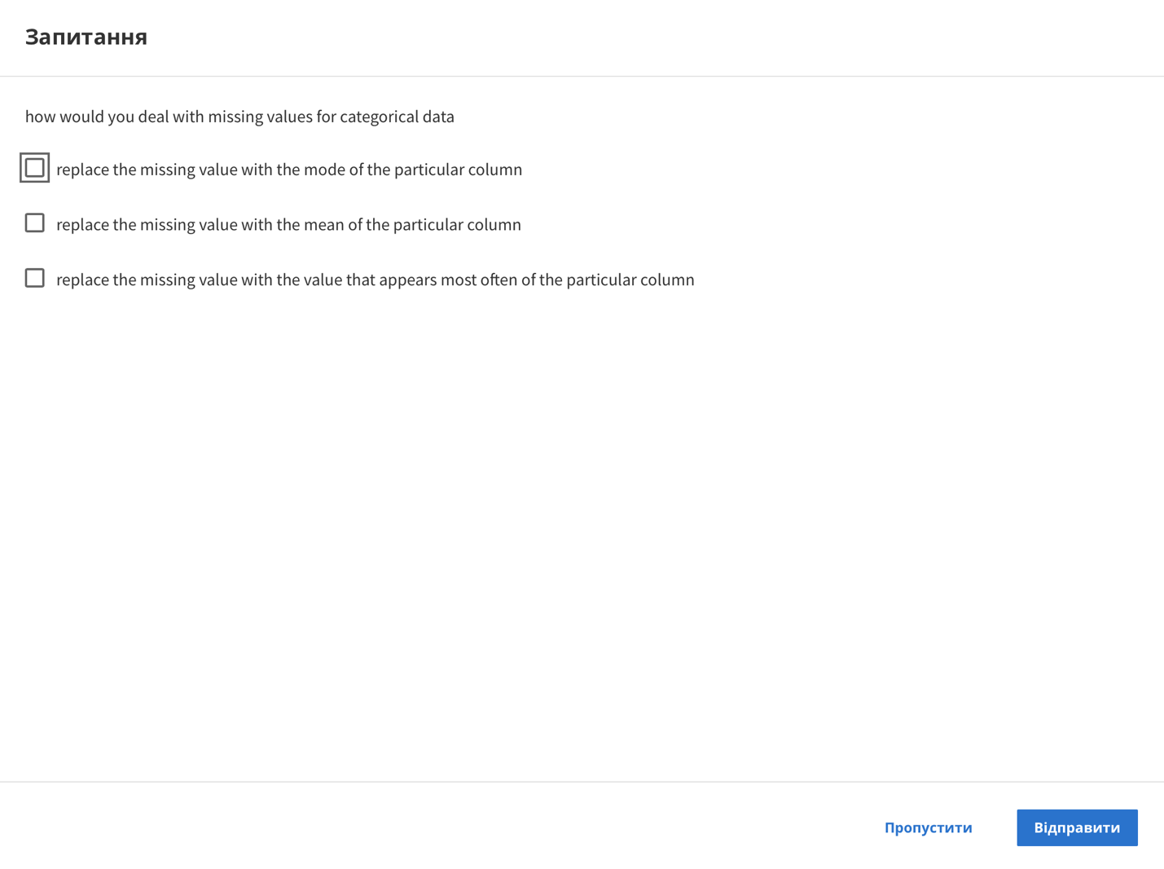

Question

how would you deal with missing values for categorical data

replace the missing value with the mode of the particular column

replace the missing value with the mean of the particular column

replace the missing value with the value that appears most often of the particular column

Skip

Send

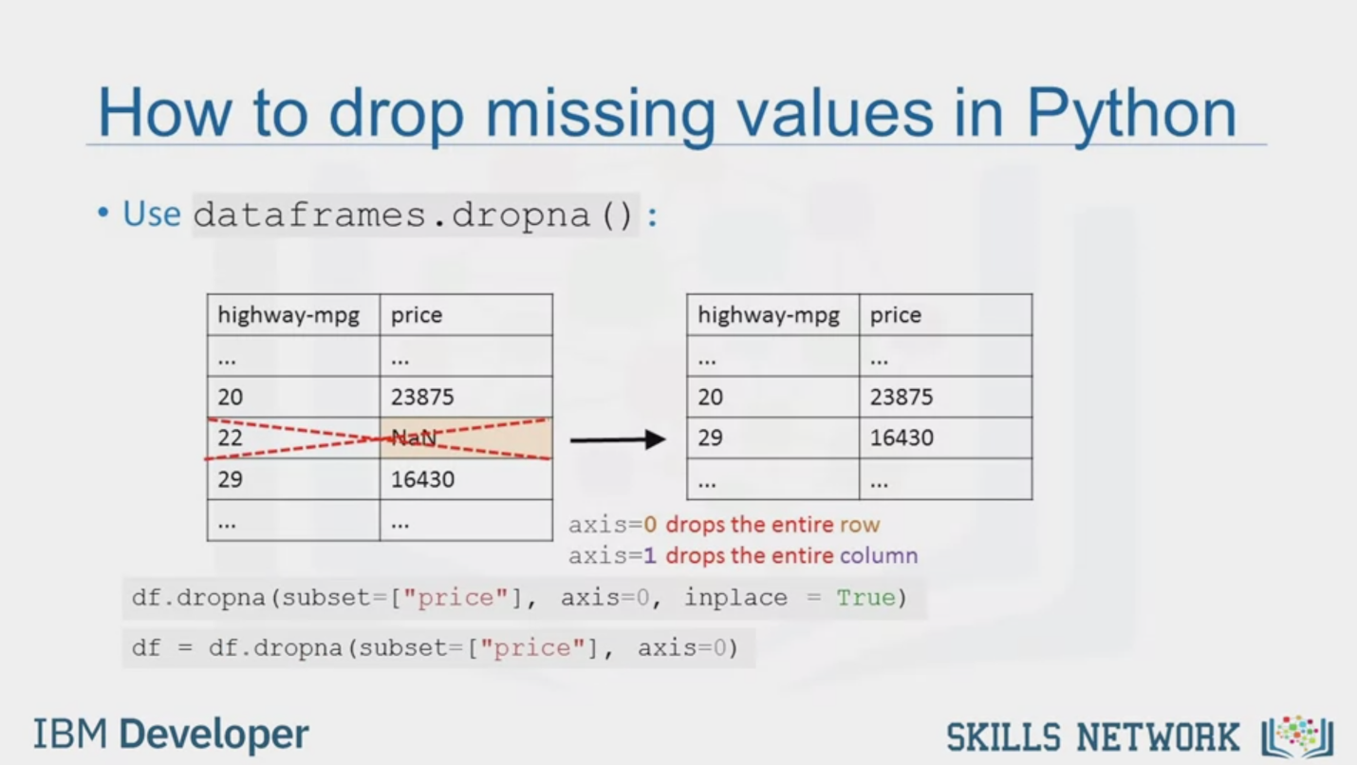

How to drop missing values in Python

• Use dataframes. dropna () :

axis=0 drops the entire row

axis=1 drops the entire column

df.dropna (subset=["price"], axis=0, inplace = True)

df = df.dropna (subset=["price"), axis=0)

IBM Developer

SKILLS NETWORK

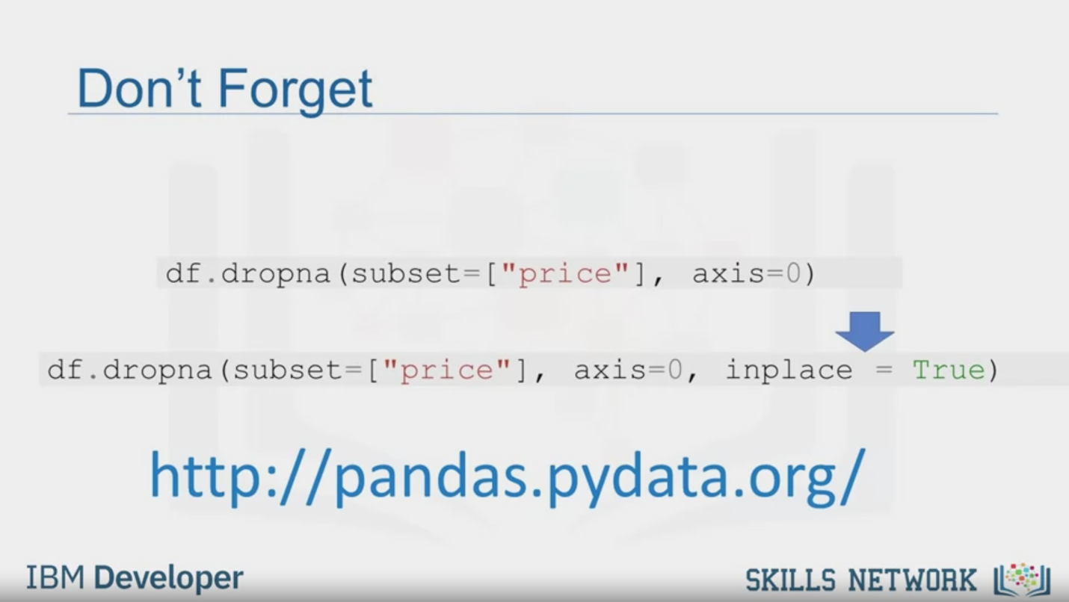

Don't Forget

df.dropna (subset=["price"], axis=0)

df.dropna (subset=["price"], axis=0, inplace=True)

http://pandas.pydata.org/

IBM Developer

SKILLS NETWORK

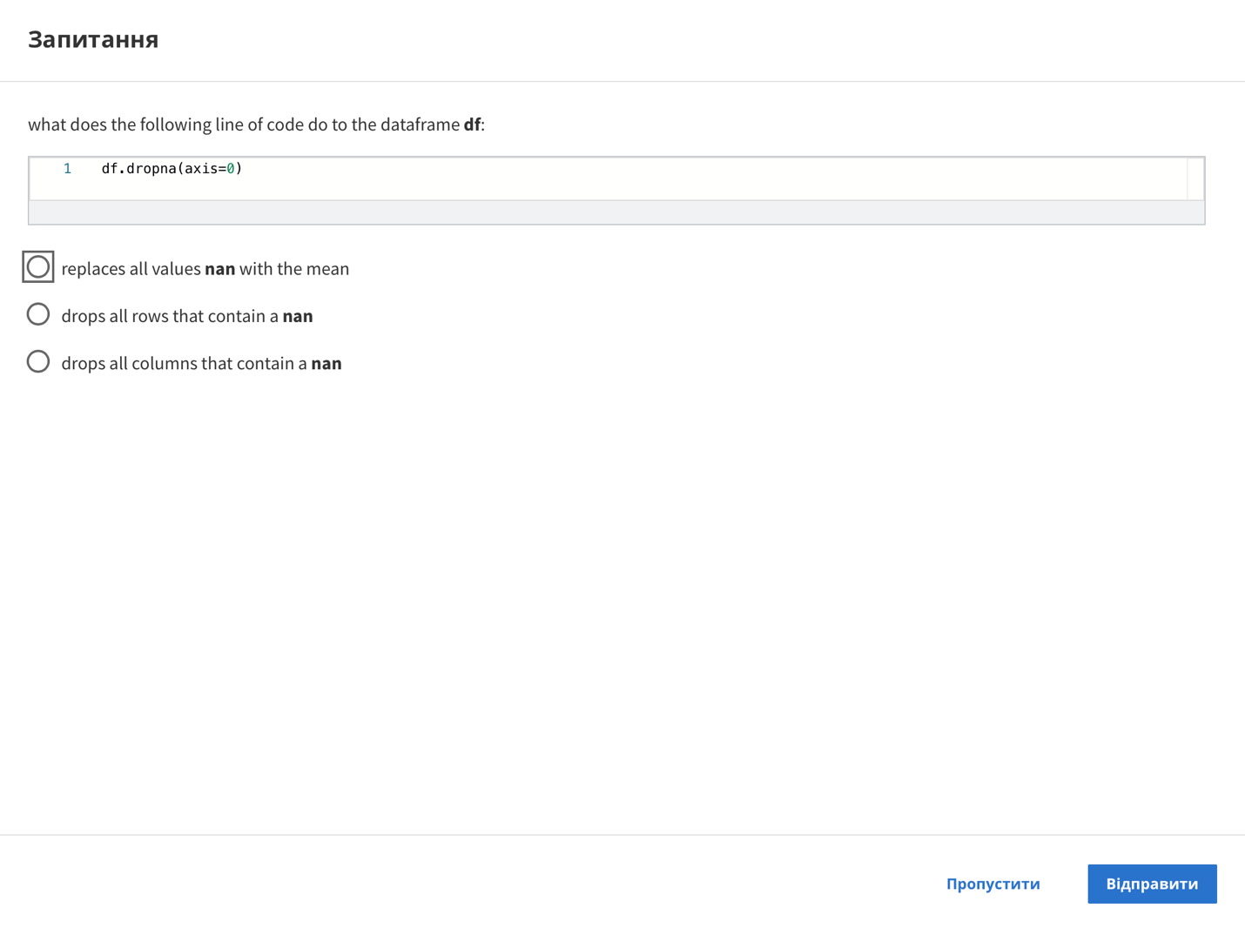

Question

what does the following line of code do to the dataframe df:

1 df. dropna(axis=0)

replaces all values nan with the mean

drops all rows that contain a nan

drops all columns that contain a nan

Skip

Send

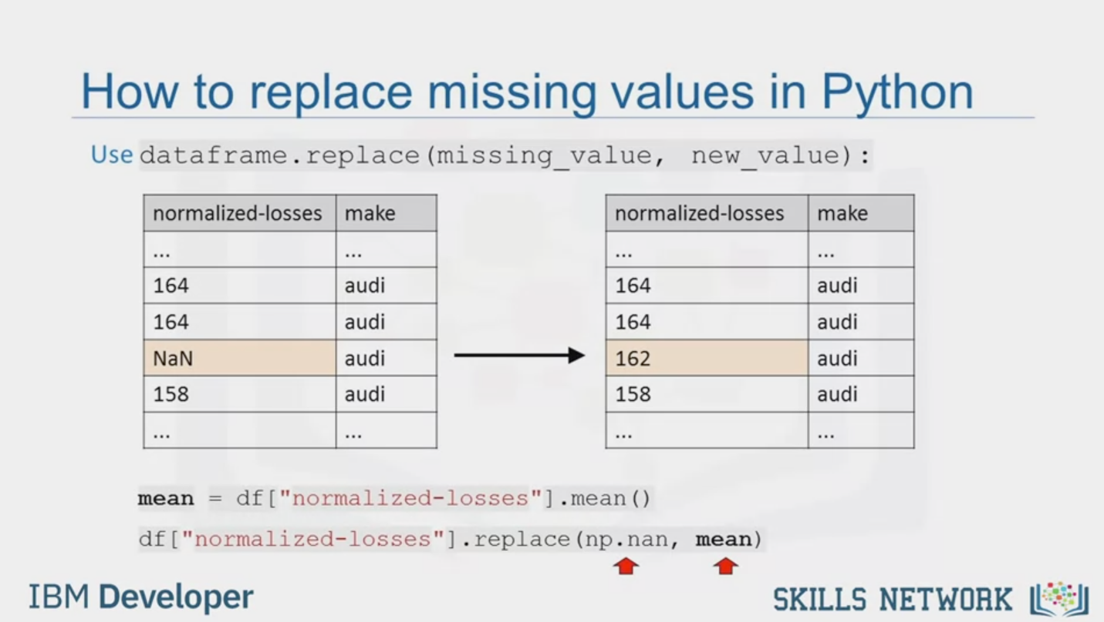

How to replace missing values in Python

Usedataframe.replace (missing_value, new_value):

mean = df ["normalized-losses"] .mean ()

df ["normalized-losses"].replace (np.nan, mean)

IBM Developer

SKILLS NETWORK

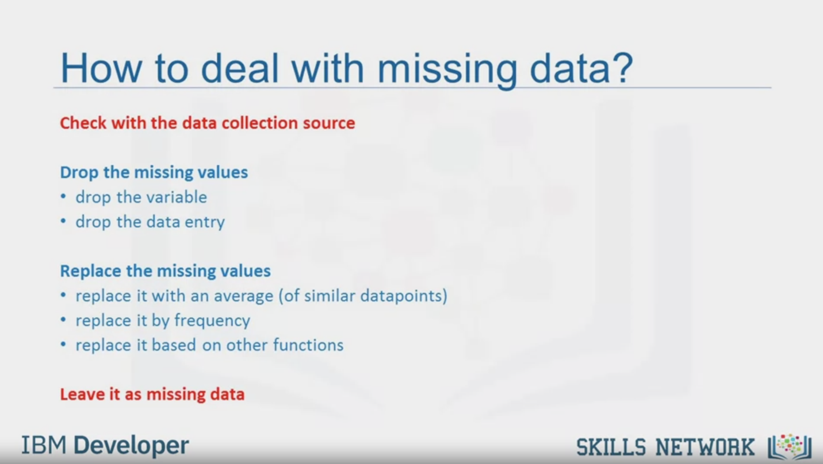

How to deal with missing data?

Check with the data collection source

Drop the missing values

• drop the variable

• drop the data entry

Replace the missing values

• replace it with an average (of similar datapoints)

• replace it by frequency

• replace it based on other functions

Leave it as missing data

IBM Developer

SKILLS NETWORK



SKILLS NETWORK

IBM Developer

In this video, we will introduce the pervasive problem of

missing values as well as strategies

on what to do when you encounter missing values in your data.

When no data value is stored for feature for a particular observation,

we say this feature has a missing value.

Usually missing value in data set appears as

question mark and a zero or just a blank cell.

In the example here,

the normalized losses feature has a missing value which is represented with NaN.

But how can you deal with missing data?

There are many ways to deal with missing values and this is regardless of Python,

R or whatever tool you use.

Of course, each situation is different and should be judged differently.

However, these are the typical options you can consider.

The first is to check if the person or group that collected

the data can go back and find what the actual value should be.

Another possibility is just to remove the data where that missing value is found.

When you drop data, you could either drop the whole

variable or just the single data entry with the missing value.

If you don't have a lot of observations with missing data,

usually dropping the particular entry is the best.

If you're removing data, you want to look

to do something that has the least amount of impact.

Replacing data is better since no data is wasted.

However, it is less accurate since we need to

replace missing data with a guess of what the data should be.

One standard for placement technique is to replace

missing values by the average value of the entire variable.

As an example, suppose we have some entries that have missing values for

the normalized losses column and the column average for entries with data is 4500.

While there is no way for us to get an accurate guess of what

the missing value is under the normalized losses column should have been,

you can approximate their values using the average value of the column 4500.

But what if the values cannot be averaged as with categorical variables?

For a variable like fuel type,

there isn't an average fuel type since the variable values are not numbers.

In this case, one possibility is to try using the mode,

the most common like gasoline.

Finally, sometimes we may find another way to guess the missing data.

This is usually because the data gathered

knows something additional about the missing data.

For example, he may know that the missing values tend to be

old cars and the normalized losses of

old cars are significantly higher than the average vehicle.

And of course, finally,

in some cases you may simply want to leave the missing data as missing data.

For one reason or another,

it may be useful to keep that observation even if some features are missing.

Now, let's go into how to drop missing values or replace missing values in Python.

To remove data that contains missing values

Panda's library has a built-in method called dropna.

Essentially, with the dropna method,

you can choose to drop rows or columns that contain missing values like NaN.

So you'll need to specify access equal zero to drop

the rows or access equals one to drop the columns that contain the missing values.

In this example, there is a missing value in the price column.

Since the price of used cars is what we're trying to predict in our upcoming analysis,

we have to remove the cars,

the rows, that don't have a listed price.

It can simply be done in one line of code using dataframe.dropna.

Setting the argument in place to true,

allows the modification to be done on the data set directly.

In place equals true,

just writes the result back into the data frame.

This is equivalent to this line of code.

Don't forget that this line of code does not change

the data frame but is a good way to

make sure that you are performing the correct operation.

To modify the data frame,

you have to set the parameter in place equal to true.

You should always check the documentation if

you are not familiar with the function or method.

The pandas web page has lots of useful resources.

To replace missing values like NaNs with actual values,

Pandas library has a built-in method called replace which can be

used to fill in the missing values with the newly calculated values.

As an example, assume that we want to replace the missing values of

the variable normalized losses by the mean value of the variable.

Therefore, the missing value should be replaced

by the average of the entries within that column.

In Python, first we calculate the mean of the column.

Then we use the method replace to

specify the value we would like to be replaced as the first parameter,

in this case NaN.

The second parameter is the value we would

like to replace it with i.e the mean in this example.

This is a fairly simplified way of replacing missing values.

There are of course other techniques such as replacing

missing values for the average of the group instead of the entire data set.

So, we've gone through two ways in Python to deal with missing data.

We learnt to drop problematic rows or columns containing

missing values and then we learnt how to replace missing values with other values.

But don't forget the other ways to deal with missing data.

You can always check for a higher quality data set or source

or in some cases you may want to leave the missing data as missing data.